**9 SCIENCE 2014**

### GEOLOGY AND EARTH SCIENCE TEST ONE

Name: ____________________ Teacher: ___________________ Mark: /48

**Percentage: %**

**SECTION A: MULTIPLE CHOICE (15 marks)**

**Please answer on the multiple choice answer grid below.**

1. A B C D 10. A B C D

2. A B C D 11. A B C D

3. A B C D 12. A B C D

4. A B C D 13. A B C D

5. A B C D 14. A B C D

6. A B C D 15. A B C D

7. A B C D

8. A B C D

9. A B C D

1. Alfred Wegener proposed the theory of continental drift. Which of the following observations did he use to support his theory?

(a) Fossils could be found in different countries.

(b) Africa and South America seemed to fit together like jigsaw pieces.

(c) Rocks had magnetic striping near the ocean ridges.

(d) The sea floor seemed to be made at the ridges.

2. Harry Hess proposed a mechanism by which Wegener’s continental drift could occur. Hess’s theory was called:

(a) plate tectonics.

(b) continental drift.

(c) seafloor spreading.

(d) subduction.

3. Magnetite is a magnetic mineral that can be found in basalt, which is common in oceanic crust. Magnetite enabled scientists to obtain evidence of:

(a) seafloor spreading.

(b) Earth’s magnetic field.

(c) subduction.

(d) tectonic plates.

4. Rifting is the process of:

(a) ocean trenches forming by collision of plates.

(b) the crust subducting.

(c) plates moving by sliding past each other.

(d) the crust cracking and subsiding.

5. Evidence of spreading of the crust at ocean ridges resulted from:

(a) seismic activity in the Earth’s crust.

(b) differences in density of oceanic and continental crust.

(c) subduction of plates at collision boundaries.

(d) reversals in the Earth’s magnetic field.

6. The diagram on the right illustrates:

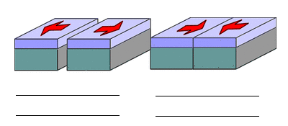

(a) converging boundaries.

(b) transform boundaries.

(c) diverging boundaries.

(d) colliding boundaries.

7. Using the map below, choose the **correct** statement:

(a) The Pacific and Nazca Plates are converging.

(b) The is a transform boundary between the Nazca and Caribbean Plates.

(c) The Nazca and South American Plates are converging.

(d) All of the above.

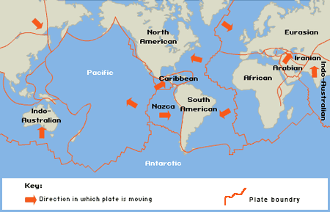

8. Four of the seven largest tectonic plates are:

(a) the African Plate, Eurasian Plate, Antarctic Plate and Nazca Plate.

(b) the Eurasian Plate, Pacific Plate, Nazca Plate and Antarctic Plate.

(c) the Antarctic Plate, North American Plate, Eurasian Plate and African Plate.

(d) the Pacific Plate, Caribbean Plate, Antarctic Plate and Eurasian Plate.

9. Iron oxide mineral in rocks that acts as a compass is known as:

(a) mineralite.

(b) mangetite.

(c) magnetite.

(d) magnatite.

10. Select the **incorrect** statement below.

(a) There are nearly 200 species of marsupials in Australia.

(b) Around 80% of Western Australia’s flora is found no where else.

(c) Australia’s isolation led to the evolution of unique species of plants and animals in Australia.

(d) Australia has the monotremes, which are unique to Australia and South America.

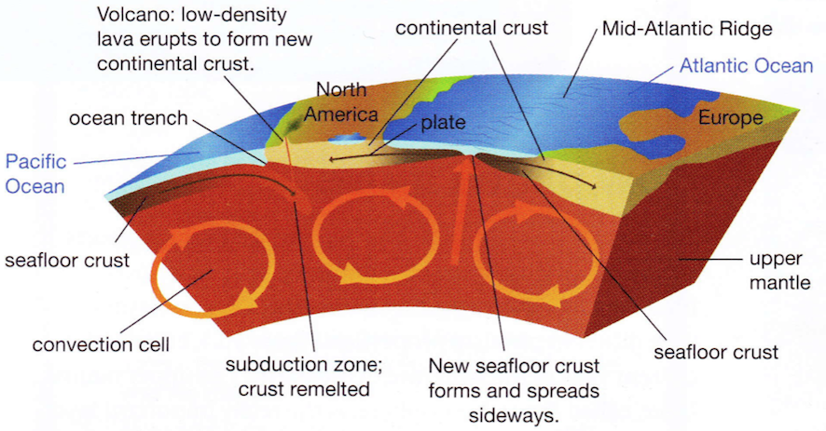Question 11 and 12 refer to the diagram below.

11. The diagram is being used to show that:

(a) the Earth is composed of layers.

(b) continents are formed by seafloor spreading.

(c) plate tectonics can change the Earth’s climates.

(d) tectonic plates move due to convection currents.

12. From the diagram you could conclude that subduction and seafloor spreading together:

(a) cause the convection currents.

(b) show that the crust is recycled and therefore does not grow larger.

(c) explain the formation of North America and Europe.

(d) explain why volcanoes form from magma originating in the crust.

13. The presence of ‘magnetic stripes’ recorded in the oceanic crust reflects:

(a) the rate of sea floor spreading.

(b) reversals in polarity of the Earth’s magnetic field.

(c) variation in composition of the oceanic crust.

(d) the unchanging polarity of the Earth’s magnetic field.

14. In 1872 when scientists were surveying for an undersea cable they discovered:

(a) a large mountain ridge in the middle of the Atlantic Ocean.

(b) a large trench in the middle of the Antarctic Ocean.

(c) a large mountain ridge in the middle of the Antarctic Ocean.

(d) a large trench in the middle of the Atlantic Ocean.

15. Measurements from which stations show the rates of plate movement accurate to a few millimetres?

(a) Strainmeter stations.

(b) GPS stations.

(c) Earthquake stations.

(d) Tectonic movement stations.

**SECTION B: SHORT ANSWER (33 marks)**

**1a.** State the name given to the large landmass that all the continents were once part of. (3 marks)

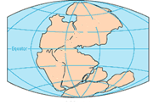

_____________________________________________

**b.** This landmass broke into two major landmasses known as:

____________________________ and __________________________

**2.** At diverging boundaries, seafloor spreading is occurring as new crust is continuously created. Explain why the Earth’s crust is not getting any bigger. (2 marks)

_____________________________________________________________________________________

_____________________________________________________________________________________

_____________________________________________________________________________________

**3.** Fill in the table below which compares the characteristics of oceanic crust and continental crust. (2 marks)

|  |  |  |  |
| --- | --- | --- | --- |
| Type of crust | Thin or thick | Dark or light  coloured | Has low density or high density |
| Continental  crust |  |  |  |
| Oceanic  crust |  |  |  |

**4.** Label the diagram below. (3 marks)

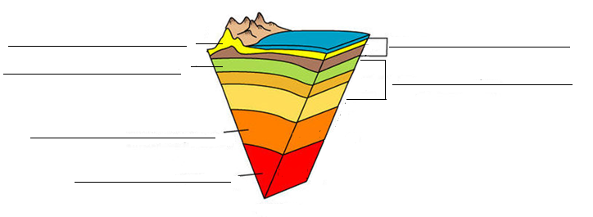

**5.** Use your knowledge of what happens when an oceanic plate collides with a continental plate to answer the following questions.

**a.** Explain why the oceanic plate is forced under the continental plate. (2 marks)

_____________________________________________________________________________________

_____________________________________________________________________________________

_____________________________________________________________________________________

**b.** Outline the process of subduction. (2 marks)

_____________________________________________________________________________________

_____________________________________________________________________________________

_____________________________________________________________________________________

**c.** Explain why volcanoes often form on the continental plate after the collision. (2 marks)

_____________________________________________________________________________________

_____________________________________________________________________________________

_____________________________________________________________________________________

**6.** Explain the role of heat and convection in plate movement. (2 marks)

_____________________________________________________________________________________

_____________________________________________________________________________________

**7.** Match the terms to their definitions by writing the number of the correct definition in the box.(5 marks)

|  |  |  |  |
| --- | --- | --- | --- |
|  | **TERM** |  | **DEFINITION** |
|  | Harry Hess | 1. | Large pieces of crust which move on the asthenosphere are called _______ _______ |
|  | Subduction | 2. | The movement of the tectonic plates over time which creates a change in distance between the continents ….occurs very gradually. |
|  | Continental drift | 3. | The scientist who proposed the theory of seafloor spreading. |
|  | Rifting | 4. | The scientist who proposed the theory that continents separated and are drifting across the oceans. |
|  | Continental crust | 5. | Layer of crust under the level of the water. |
|  | Seafloor spreading | 6. | The occurrence of ancient skeletal remains of animal and plant material that are found in rock formation. |
|  | Alfred Wegener | 7. | Formation of new rocky crust at the ocean ridges and spreading outwards. |
|  | Tectonic plate | 8. | The process of crust sinking. |
|  | Oceanic crust/ seafloor crust | 9. | A process by which continents broke up – the crust cracked and subsided allowing in the oceans. |
|  | Fossil evidence | 10. | Layer of crust containing land mass above sea level. |

**8.** Explain why the sedimentary rock layers on the ocean floor are thicker as you move away from the ridges. (2 marks)

_____________________________________________________________________________________

_____________________________________________________________________________________

_____________________________________________________________________________________

**9.** Write the correct term on the line next to each definition. (8 marks)

|  |  |  |
| --- | --- | --- |
| ______________________________ | 1. | A layer of “plastic like” semi-solid rock in the upper mantle. |
| ______________________________ | 2. | Where plates are sliding parallel to each other but in the opposite direction. |
| ______________________________ | 3. | A deep trench in the ocean floor that is much deeper than the rest of the ocean floor. |
| ______________________________ | 4. | Where plates are moving apart from each other in opposite directions. |
| ______________________________ | 5. | Where plates are colliding with each other. |
| ______________________________ | 6. | A chain of islands formed at the edges of colliding tectonic plates where one plate subducts. |
| ______________________________ | 7. | An ocean current that extended from the polar region bringing very cold ocean temperatures. |
| ______________________________ | 8. | Name given to scientist who study the earth, its formation, mineral deposits and rock structures. |